**Homework:** Draw by hand the binary search tree when we insert the following key’s

into an empty tree:

1. 15, 12, 9, 56, 1, 16, 19, 22, 3, 100, 2, 25

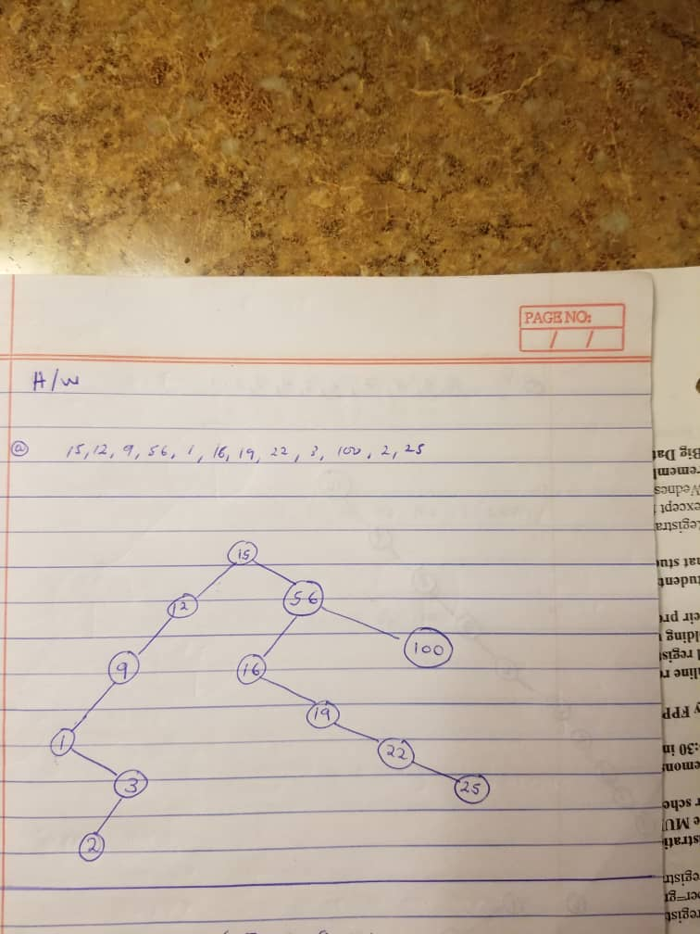

1. 1, 2, 3, 4, 5, 6, 7, 8, 9, 10

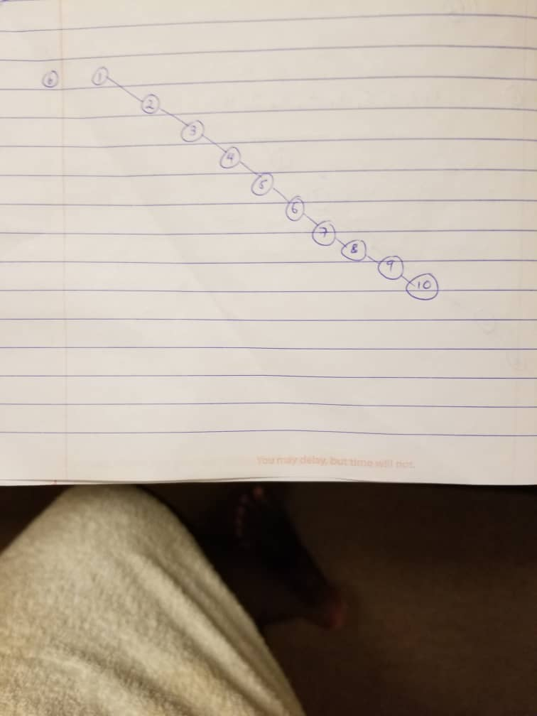

1. 10, 9, 8, 7, 6 ,5, 4, 3, 2, 1

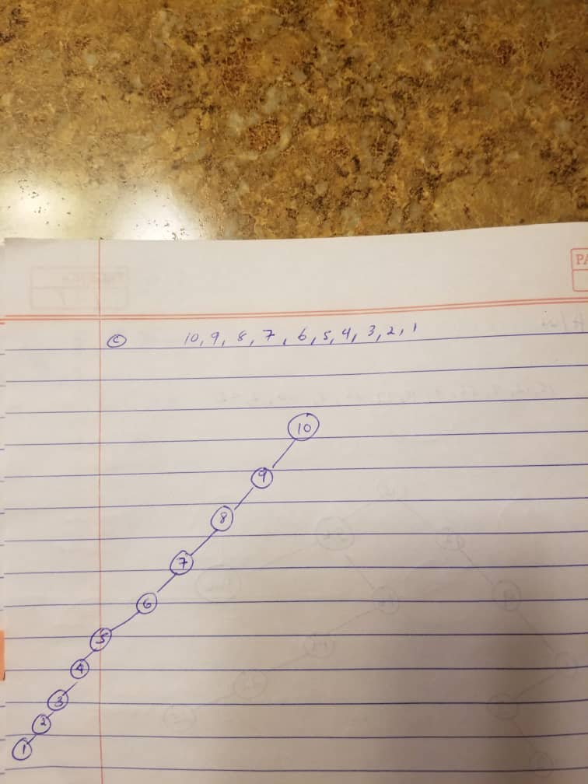

1. Give the order of the nodes that are visited during preorder, inorder and postorder traversal from the tree of part a.

**Pre-Order Traversal (VLR)**

15, 12, 9, 1, 3, 2, 56, 16, 19, 22, 25, 100

**Post-Order Traversal (LRV)**

2, 3, 1, 9, 12, 25, 22, 19, 16, 100, 56, 15

**In-Order Traversal (LVR)**

1, 2, 3, 9, 12, 15, 16, 19, 22, 25, 56, 100